**Data Transmission using LIFI technology**

**Submitted**

**By**

**Munendrakumar LK -BU21EECE0100572**

**Niranjan GN-BU21EECE0100485**

**chavva Hitesh reddy -BU21EECE0100499**

**Under the Guidance of**

**-DR Subhashish Tiwari Sir, assistant professor**



**Department of Electrical,Electronics and Communication Engineering**

**GITAM School of Technology**

**GITAM**

**(DEEMED TO BE UNIVERSITY)**

**(Estd. u/s 3 of the UGC act 1956)**

**NH 207, Nagadenehalli, Doddaballapur taluk, Bengaluru-561203 Karnataka, INDIA.**

**DECLARATION**

**I/We declare that the project work contained in this report is original and it has been done by me under the guidance of my project guide.**

**Name:**

**Date: Signature of the Student**

**Department of Electrical,Electronics and Communication Engineering**

**GITAM School of Technology, Bengaluru-561203**



**CERTIFICATE**

**This is to certify that (Student Name) bearing (Regd. No.:) has satisfactorily completed Mini Project Entitled in partial fulfillment of the requirements as prescribed by University for VIIIth semester, Bachelor of Technology in “Electrical, Electronics and Communication Engineering” and submitted this report during the academic year 2024-2025.**

**[Signature of the Guide] [Signature of HOD**

Abstract:

In this project, we plan to build a long-range, high-speed 5G Li-Fi model that can function in all types of indoor systems. We also intend to integrate audio and video transmission.

The exponential growth of data consumption in the digital era necessitates innovative technologies that can complement traditional communication systems. Light Fidelity (Li-Fi), an emerging wireless communication technology, leverages visible light for data transmission and offers unprecedented bandwidth and speed. Integrating Li-Fi with 5G networks presents a transformative solution to address challenges such as spectrum congestion, latency, and energy efficiency.

This study explores the potential of Li-Fi to enhance high-speed 5G data transmission, focusing on its ability to support ultrafast connectivity in environments where radiofrequency (RF) technologies face limitations. Key areas of investigation include the modulation techniques used in Li-Fi, the architecture of hybrid Li-Fi and RF systems, and the optimization of light sources such as LEDs for communication purposes.

We reffered some reasurch papers according to their Simulation and experimental results highlight the advantages of Li-Fi in achieving data rates exceeding 10 Gbps, reduced latency, and enhanced security, making it ideal for applications like autonomous vehicles, smart cities, and industrial automation. Challenges such as line-of-sight requirements, interference from ambient light, and integration with existing 5G infrastructure are also addressed, along with proposed solutions.

The findings underscore the transformative role of Li-Fi in complementing 5G technologies, paving the way for a robust, energy-efficient, and ultra-fast communication ecosystem. This research contributes to the ongoing discourse on next-generation wireless networks and their impact on future connectivity paradigms.

**Table of contents**

**Chapter 1: Introduction 1**

1.1 Overview of the problem statement 1

1.2 Objectives and goals 1

**Chapter 2 : Literature Review 2**

**Chapter 3 : Strategic Analysis and Problem Definition 3**

3.1 SWOT Analysis 3

3.2 Project Plan - GANTT Chart 3

**Chapter 4 : Methodology 4**

4.1 Description of the approach 4

4.2 Tools and techniques utilized 4

4.3 Design considerations 4

**Chapter 5 : Implementation 5**

5.1 Description of how the project was executed 5

5.2 Challenges faced and solutions implemented 5

**Chapter 6:Results 6**

**Chapter 7: Conclusion 7**

**Chapter 8 : Future Work 8**

8

**9**

# **Chapter 1: Introduction**

## 1.1 Overview of the problem statement

Li-Fi (Light Fidelity) technology is a wireless communication system that uses visible light, infrared, or near-ultraviolet light to transmit data. It is considered an alternative to traditional Wi-Fi, which uses radio waves for communication. Li-Fi has several potential advantages, including higher data transmission speeds, more secure communication, and the ability to operate in environments where radio frequency (RF) technologies might interfere or be prohibited, such as hospitals or airplanes.

Overview of the Problem Statement in Li-Fi Technology

1. Bandwidth Limitation in RF Systems:

Traditional wireless communication systems such as Wi-Fi are constrained by limited bandwidth in the radio frequency spectrum. With increasing data demands due to the rise of IoT devices, streaming, and cloud-based services, RF-based systems face congestion, leading to slower data speeds and connectivity issues.

2. Security and Interference:

RF signals can penetrate walls, making Wi-Fi networks vulnerable to hacking. Additionally, interference with other RF-based systems and electronic devices is a common issue, especially in densely populated or high-tech environments.

3. Energy Efficiency:

Wireless communication systems based on radio frequencies consume significant energy. The growing number of wireless devices increases overall power consumption, creating an energy challenge for future networks.

4. Li-Fi as a Solution:

1. High Data Transmission Speed: Li-Fi can offer extremely high-speed data transmission. Since light has a much higher frequency spectrum compared to radio waves, it allows for greater data capacity and speed.
2. Security: Since light waves cannot penetrate walls, Li-Fi provides enhanced security by limiting the signal to a confined area, reducing the risk of unauthorized access.
3. Interference-Free Communication: Li-Fi does not cause interference with RF systems, making it suitable for environments like hospitals, airplanes, or factories, where electronic interference needs to be minimized.
4. Energy Efficiency: Li-Fi systems can utilize existing lighting infrastructure (such as LED lights) to transmit data, reducing the need for additional energy consumption.

5. Challenges:

1. Line of Sight Requirements: One of the main limitations of Li-Fi technology is the need for a direct line of sight between the transmitter (light source) and the receiver. This makes it less versatile compared to RF systems, which can transmit data through walls.
2. Limited Range: Since light-based communication systems cannot travel long distances as effectively as RF systems, Li-Fi systems are generally limited to small areas.
3. Adaptation and Infrastructure: Widespread adoption of Li-Fi would require significant changes to infrastructure, including the installation of Li-Fi-enabled LED lighting and devices capable of receiving optical signals.

Problem Statement in Summary

The problem statement of Li-Fi technology revolves around the limitations of traditional RF-based wireless communication systems, such as bandwidth congestion, security vulnerabilities, interference, and energy consumption. Li-Fi aims to address these problems by leveraging visible light for wireless data transmission. However, it faces its own set of challenges, such as limited range and line-of-sight requirements.

## 

## 1.2 Objectives and goals

Objectives

* Designing the LIFI model to transfer high-speed 5g data, ideal for use in indoor environments such as offices, hospitals, and homes, where high-speed internet is required and interference needs to be minimized.
* Smart Lighting Systems: Integration with smart lighting systems enables communication while providing illumination, making it suitable for smart cities and intelligent buildings

Goals

* The goal is to harness visible light for data transmission, offering an alternative to traditional Wi-Fi with enhanced bandwidth, reduced interference, and improved security.
* Energy Efficiency: Optimize the Li-Fi system for minimal energy consumption by utilizing LED lighting, which serves a dual purpose of illumination and data transmission, contributing to energy savings in smart buildings and other applications
* Scalability and Flexibility:. Create a modular and scalable architecture for Li-Fi that can be easily expanded to accommodate a growing number of users and devices, including support for IoT and smart city applications

# Chapter 2 : Literature Review

|  |  |  |
| --- | --- | --- |
| Author and Domain | Methodology | Drawbacks |
| **1)A Review of LiFi Technology**  A. Singh, R. Kumar  Integration of LiFi in 5G Telemedicine Systems  **2)Integration of Dimming into LiFi Systems**  *Trang Nguyen  School of Engineering, Institute for  Digital Communications, LiFi R&D  Centre, the University of Edinburgh  Edinburgh, UK  **3)LiFi Technology in Healthcare Environments**  J. Brown, P. Lee  **4)High-Speed Communication in 5G Hospitals**  M. Ali, S. Patil | 1. LiFi reduces electromagnetic interference, ensuring secure and high-speed data transmission for real-time telemedicine consultations.   *Line-of-sight dependence limits usability in dynamic medical environments.  *Optimizing hybrid LiFi-WiFi systems for seamless connectivity in hospitals.  **Photodetector**: The receiving device contains a photodetector (often a photodiode), which captures the modulated light and converts it back into electrical signals  Keywords—LiFi, Dimming, PWM dimming, AM dimming,  *Different dimming methods (AM dimming, PWM  dimming, and hybrid dimming methods) were implemented  dimming reduces the communication quality of both DCO-  OFDM and ASE-DMT.  * discusses the importance of modulation schemes in LiFi systems. They explore **Orthogonal Frequency Division Multiplexing (OFDM)** as a key modulation technique for LiFi  LiFi offers interference-free operation near sensitive medical equipment, supporting remote monitoring with high-speed connectivity.  Development of multi-user LiFi systems with adaptive beam steering to improve coverage.  Successful use of LiFi for high-speed medical imaging transfer and secure patient data transmission in controlled indoor environments  Research into cost-effective LiFi solutions and standardization for hospital adoption. | A.) FLICKERING –It is an effect which occurs due to turning  ON and OFF of LED, since LED plays two roles When data is transfer from LED the fluctuation occurs  due to ON-OFF mode which affects the illumination  process of LED. It is one of the major challenges of LiFi  which has to be overcome because flickering affects  human vision.  B.) Line of Sight – The efficiency of LiFi can be achieved  only with Line-of-Sight communication. If either  receiver/transmitter moves from its desired position then  miscommunication may occur .  C). Interference of external light D. Separate LED should be used for each room because light  cannot penetrate thought the wall or any solid object.  *Limited Range Coverage Area  *Interference from Ambient Light  *Signal Attenuation Absorption and Scattering  * Data Transmission Through Opaque Materials  Inability to Penetrate Walls  Physical barriers like walls or large medical devices obstruct LiFi signals.  High initial infrastructure cost and compatibility issues with existing medical systems |

# Chapter 3 : Strategic Analysis and Problem Definition

# SWOT Analysis

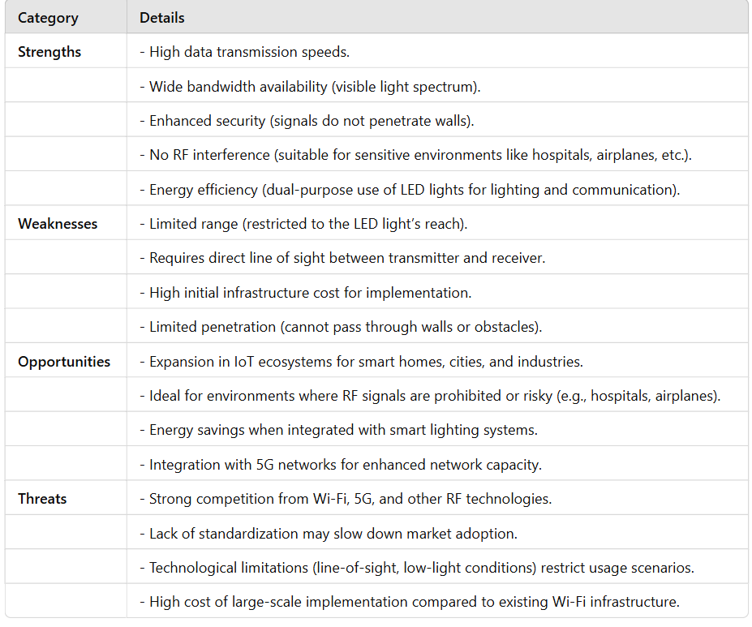

### 3.2 Project Plan

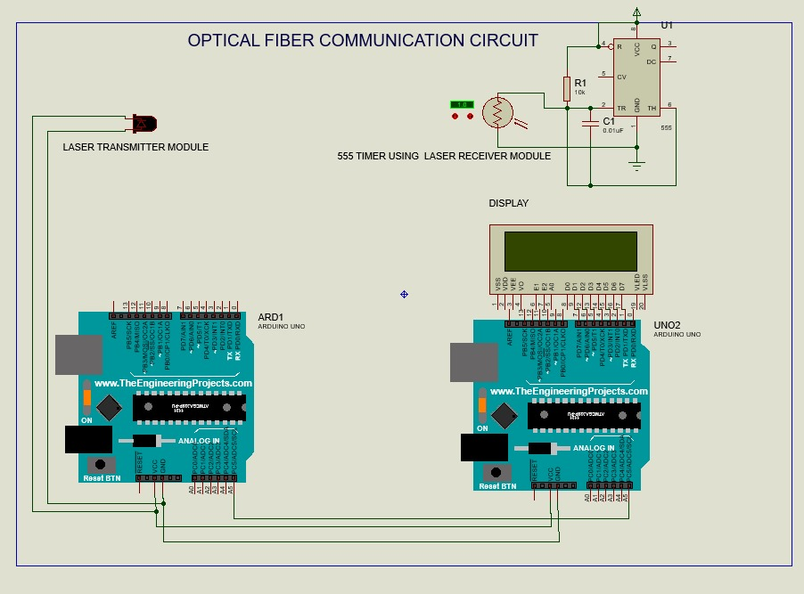

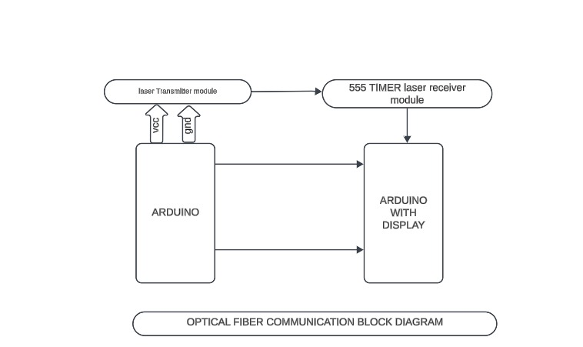

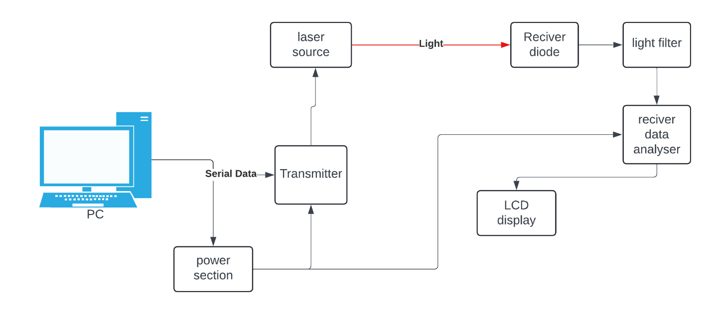

Components information

1)PC: It is used as an input device for uploading and compiling the code.

2) ARDUINO: We are using this microcontroller for processing the data in both the transmitter and receiver sections.

3) LASER TRANSMITTER MODULE: We will use this as a transmitter.

4) DISPLAY MODULE: This is an output device.

5)555 TIMER: The 555 timer is a versatile and widely used integrated circuit (IC) that can be employed in various modulation techniques, including  those used in LiFi (Light Fidelity) technology

**Pulse Generation**: The 555 timer can generate precise pulses, which are essential for modulation techniques.

**Pulse Width Modulation (PWM)**: This technique can be used to control the intensity of the light source in LiFi systems.

**Timing and Oscillation**: The 555 timer can create accurate time delays and oscillations, which are crucial for synchronizing data transmission.

**Project Plan (Clearly mention milestone for objectives under each reviews)**

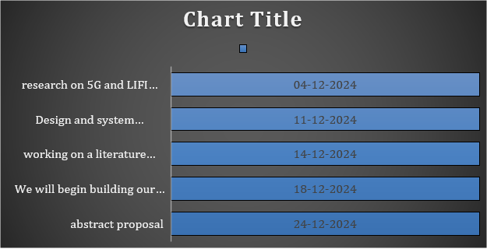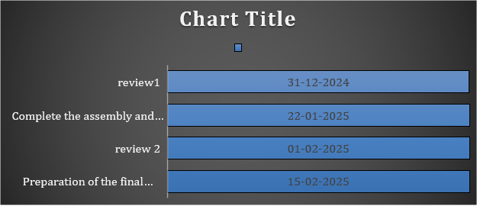

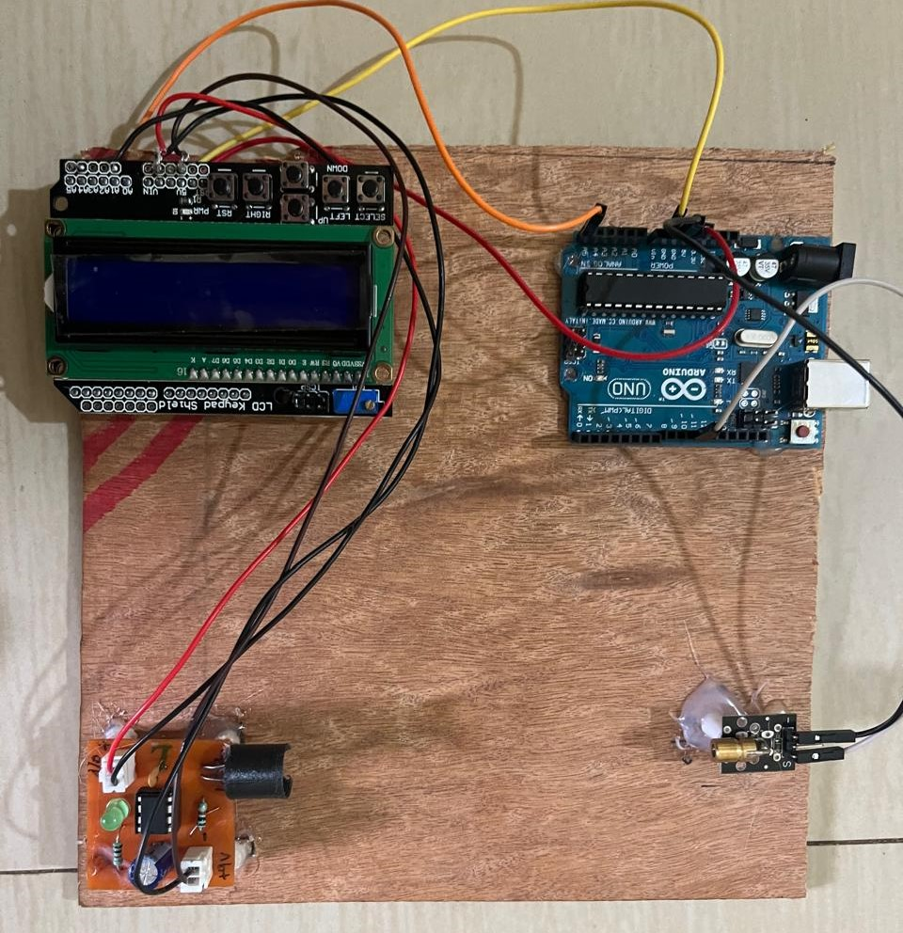

**Working Protocol:**

**Step 1: System Initialization**

* Arduino powers up, initializes the **LCD display**, **laser sensor**, and **buzzer module**.
* LCD might display a message like **"System Ready"**.

**Step 2: Laser Sensor Monitoring**

* The **laser sensor module** emits a laser beam to detect obstacles or breaks in -the beam.
* If an object interrupts the beam, it sends a signal to **Arduino**.

**Step 3: Triggering the Alarm System**

* When the sensor detects an interruption, Arduino processes the input.
* It triggers the **buzzer circuit**, producing an alert sound.
* The LCD updates with a warning message such as **"Intruder Detected"** or **"Obstacle Detected"**.

**Step 4: User Interface (Optional)**

* The **LCD keypad shield** allows user interactions.
* Buttons can be used to reset the system, configure settings, or acknowledge alerts.

**Step 5: Reset & Repeat**

* Once the alarm condition is cleared, the system resets and resumes monitoring.
* The buzzer stops, and the LCD returns to the idle state.

**Applications**

* **Security Systems:** Detects unauthorized entry.
* **Object Detection:** Used in industrial automation.
* **Traffic Control:** Vehicle or pedestrian detection.

**I2C module**

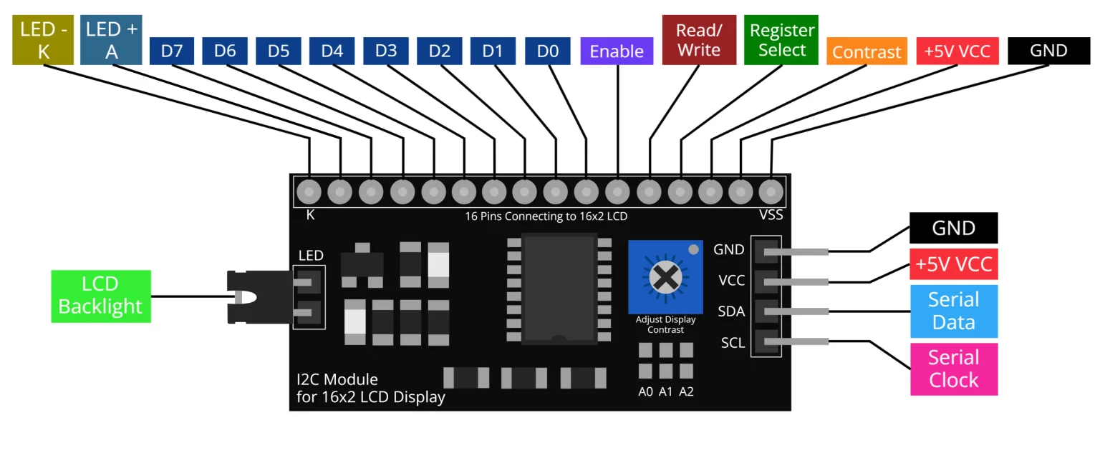

**I2C Module in Arduino**

An **I2C module** is commonly used with LCDs to reduce the number of connections required. Without an I2C module, an LCD typically requires **at least 6–8 pins**, but with an **I2C module**, it only needs **two pins** for communication:

* **SDA (Serial Data Line)**
* **SCL (Serial Clock Line)**

These pins enable multiple devices to communicate over the same bus by using unique **addresses**.

**Working of I2C Communication**

1. **Master-Slave Architecture:**
   * The **Arduino (Master)** controls the communication.
   * The **I2C module (Slave)** receives instructions.
2. **Addressing:**
   * Each I2C device has a **unique 7-bit address**.
   * The Master sends this address to specify which device it wants to communicate with.
3. **Data Transfer:**
   * Data is sent **serially** through SDA while being synchronized by SCL.
   * Devices only respond when addressed.
4. **Acknowledgment & Stop Condition:**
   * After data is received, an acknowledgment (ACK) is sent back.
   * A "STOP" condition is sent to end communication.

**Pin Configuration of I2C Module for LCD**

| **Pin** | **Description** |
| --- | --- |
| **VCC** | Power (5V) |
| **GND** | Ground |
| **SDA** | Serial Data (A4 in Arduino Uno) |
| **SCL** | Serial Clock (A5 in Arduino Uno) |

**Advantages of Using I2C Module**

**Reduces Wiring Complexity** – Only 2 communication lines needed.  
 **Allows Multiple Devices** – Can connect multiple I2C devices on the same bus.  
**Faster Communication** – Supports data speeds up to 400 kHz (Standard Mode).  
 **Efficient Power Consumption** – Ideal for low-power applications.

1. **Data Transmission**:
   * The system starts with **ARD1** (Arduino Uno) sending data signals. These signals are passed to the **laser transmitter module**.
   * now we achived the speed of 9600 baud rate
   * A **9600 baud rate** means that the data is being transferred at 9600 bits per second..
   * The laser transmitter converts the electrical signals into light signals (laser beam), which is then emitted toward the receiver.
2. **Laser Communication**:
   * The laser beam carries the modulated data through the air or optical fiber (as this is an optical communication system).
   * The 555 timer connected to the receiver side helps control the signal synchronization and timing of the data.
3. **Data Reception**:
   * The **laser receiver module** detects the incoming light signals (from the laser transmitter) and converts them back into electrical signals.
   * The received signals are sent to the second Arduino board, **UNO2**, which decodes the information.
4. **Data Display**:
   * The decoded information is displayed on the **LCD screen** connected to **UNO2**. This allows the user to visualize the transmitted data.

**Transmiter code:**

#include <SoftwareSerial.h>

#define keyy A4

SoftwareSerial mySerial(10, 11); // RX, TX

void setup() {

// Start serial communications

Serial.begin(9600);

mySerial.begin(9600);

pinMode(keyy, OUTPUT);

digitalWrite(keyy, HIGH);

Serial.println("Type something to send the data in LIFI!");

}

void loop() {

// Send data from Serial Monitor to SoftwareSerial device

if (Serial.available()) {

char inChar = Serial.read();

mySerial.write(inChar);

}

// Send data from SoftwareSerial device to Serial Monitor

if (mySerial.available()) {

char inChar = mySerial.read();

Serial.write(inChar);

}

}

**Reciver code**:

#include <SoftwareSerial.h>

#include <LiquidCrystal.h>

// LCD pin to Arduino

const int pin_RS = 8;

const int pin_EN = 9;

const int pin_d4 = 4;

const int pin_d5 = 5;

const int pin_d6 = 6;

const int pin_d7 = 7;

const int pin_BL = 10;

LiquidCrystal lcd(pin_RS, pin_EN, pin_d4, pin_d5, pin_d6, pin_d7);

SoftwareSerial mySerial(11, 10); // RX, TX

String previousData = ""; // Track last data to avoid overwriting with the same content

void setup() {

// Start serial communications

Serial.begin(9600);

mySerial.begin(9600);

pinMode(A4, INPUT);

// Setup the LCD

lcd.begin(16, 2);

lcd.setCursor(3, 0);

lcd.print("LiFi-Demo");

lcd.setCursor(0, 1);

lcd.print("Data:");

Serial.println("SoftwareSerial on A4 (RX) and A5 (TX)");

}

void loop() {

String inChar = "";

// Check if data is available from the SoftwareSerial device

if (mySerial.available()) {

inChar = mySerial.readString();

inChar.trim(); // Trim any leading/trailing whitespace

}

// Only update the LCD if there's new data and it's different from the last displayed data

if (inChar != "" && inChar != previousData && digitalRead(A1)) {

lcd.setCursor(5, 1); // Set cursor to where the data will be displayed

lcd.print(" "); // Clear previous data by overwriting with spaces

lcd.setCursor(5, 1); // Move the cursor back for new data

lcd.print(inChar); // Print the new data

previousData = inChar; // Update the last displayed data

}

delay(100); // Adjust delay for smoother performance

}

# Chapter 4 : Methodology

The diagram you provided appears to represent the **methodology of a Li-Fi communication system**, showcasing how data is transmitted and received through light signals.

1. PC (Personal Computer):

The system begins with a PC that generates data. This data is sent to the transmitter in the form of serial data.

2. Power Section:

The power section supplies the necessary electrical power to the transmitter and other components to ensure proper functioning of the system.

3. Transmitter:

The transmitter receives the serial data from the PC and prepares it to be converted into light signals. The transmitter works with the laser source to modulate the data into light waves.

4. Laser Source:

The laser source is responsible for converting the electrical signals from the transmitter into light signals. These light signals carry the data and are directed towards the receiver.

5. Light Transmission:

The modulated light from the laser travels through the air as the medium. This is the key mechanism of Li-Fi, where light, rather than radio frequencies, is used to transmit data.

6. Receiver Diode:

At the receiving end, a receiver diode (or photodiode) captures the incoming light signal. The diode converts the light signal back into an electrical signal.

7. Light Filter:

The light filter ensures that only the relevant frequencies of light (containing the data) reach the receiver diode, filtering out any unwanted light interference from the surroundings.

8. Receiver Data Analyser:

- The receiver data analyser takes the electrical signal from the receiver diode and processes it back into meaningful data. It decodes the signal to make it understandable for further use.

9. LCD Display:

Finally, the processed data can be displayed on an LCD display or other output devices, allowing the user to view the transmitted information.

Summary:

The methodology outlines the working of a basic **Li-Fi system**:

- Data is transmitted as serial data from a PC to a transmitter.

- The transmitter modulates the data into light signals using a laser source.

- The light signals are captured by a receiver diode at the receiving end.

- The light signal is filtered and decoded by a data analyser.

- The final data is displayed or utilized on an LCD or any other connected output.

### **Tools and techniques utilized:**

1. **Data Transmission**:
   * The system starts with **ARD1** (Arduino Uno) sending data signals. These signals are passed to the **laser transmitter module**.
   * The laser transmitter converts the electrical signals into light signals (laser beam), which is then emitted toward the receiver.
2. **Laser Communication**:
   * The laser beam carries the modulated data through the air or optical fiber (as this is an optical communication system).
   * The 555 timer connected to the receiver side helps control the signal synchronization and timing of the data.
3. **Data Reception**:
   * The **laser receiver module** detects the incoming light signals (from the laser transmitter) and converts them back into electrical signals.
   * The received signals are sent to the second Arduino board, **UNO2**, which decodes the information.
4. **Data Display**:
   * The decoded information is displayed on the **LCD screen** connected to **UNO2**. This allows the user to visualize the transmitted data.

#### 4.3 Design considerations

The above images are just models, but we want to implement this technology in entire indoor communication so here is the our upcoming modes

**Industries, companies, institutional design**.

Light reflectors/optical interconnection

Lifi routers and LED bulbs

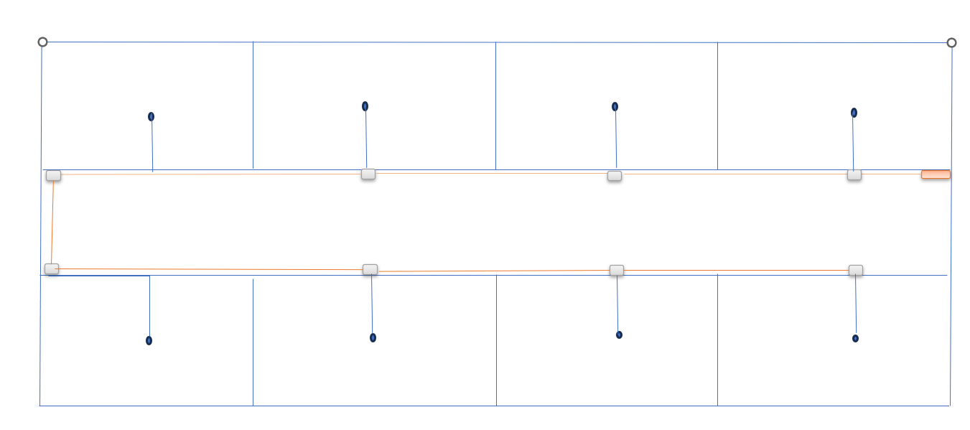

Laser transmitter

**Light reflector module**

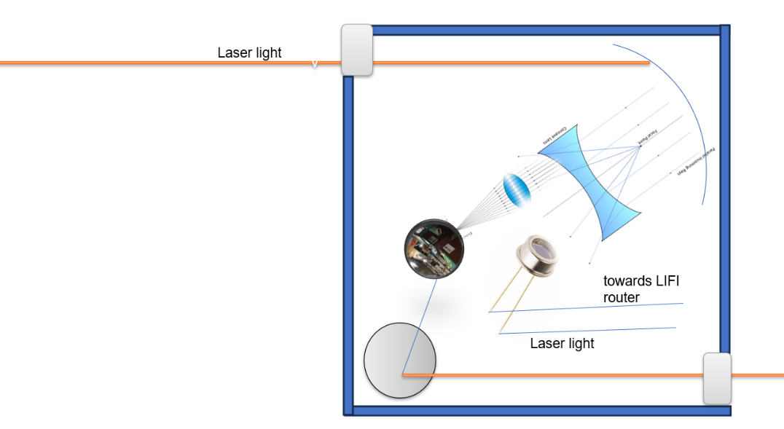

# 

# Chapter 5 : Implementation

## 5.1 Description of how the project was executed

We completely built a setup of LiFi data transmitter and receiver models. We successfully compiled and executed the transmitter and receiver code, and then uploaded it to Arduino

Then we successfully transmitted and tested multiple sets of data.

### 5.2 Challenges faced and solutions implemented

.

* **Limited Range and Line of Sight**: Since Li-Fi relies on visible light, it requires direct line of sight and is limited by physical barriers such as walls.
* **Dependence on Lighting**: The system requires lights to be turned on, which may not be ideal for all scenarios, particularly in outdoor or dim environments.
* **Infrastructure**: The widespread adoption of Li-Fi will require changes in infrastructure, including the installation of specialized lighting and receiving equipment.

We encountered various atmospheric interferences such as other LED lights and sunlight. To address this issue, we implemented a 555 timer for pulse width modulation, allowing us to transmit data successfully without any loss

**Applications & Future Scope**

**Challenges & Solutions**



# Chapter 6:Results

#### We successfully completed the transmission of data using LiFi.

# Chapter 7: Conclusion

In conclusion, while Li-Fi technology is still in its developmental phase, its unique capabilities suggest it could revolutionize data communication, particularly in specific environments where speed, security, and the lack of RF interference are critical factors

# Chapter 8 : Future Work

#### Here in the mini project, we are demonstrating the use of LiFi technology. We will definitely implement this LiFi setup in various indoor locations.

#### Li-Fi holds great promise for integration with the **Internet of Things (IoT)**, **smart cities**, and other next-generation wireless applications. It could complement existing Wi-Fi and 5G networks, offering an additional layer of connectivity in bandwidth-heavy and secure environments.

#### .

# 